POKHARA UNIVERSITY
CRIMSON COLLEGE OF TECHNOLOGY
Devinagar-11, Butwal



A Third Year Project Report On
GoFood- Online platform to order food

(PRJ– 391)

A project report submitted on behalf of partial fulfillment of Bachelor Of Computer Application
Pokhara University, Nepal

Submitted to:

Crimson College of Technology
Department of Science and Technology

Submitted by:
Samrajya Man Bhari (Symbol no: 21085160)
Suman Tachamo (Symbol no: 21085165)
Sushant Rana (Symbol no: 21085167)
Kritagya Thapa Magar (Symbol no: 21085151)

March, 2025

SUPERVISOR’S RECOMMENDATION

I hereby recommend that this report has been prepared under my supervision by Samrajya Man Bhari (21085160), Suman Tachamo (21085165), Sushant Rana(21085167), Kritagya Thapa Magar(21085151) entitled “GoFood” in partial fulfillment of the requirements for the degree BCIS(Bachelor of Computer Information & System) be processed for evaluation.

……...................................

Mr. Chiranjivi Regmi

Project Supervisor

Department of Science and Technology
Crimson College of Technology

ACKNOWLEDGEMENT

We express our sincere gratitude to Crimson College of Technology, Butwal for their invaluable resources and consistent support throughout our project. The college's commitment to academic excellence has significantly influenced our educational journey, and we appreciate the tools and guidance provided.

A special acknowledgement goes to Mr. Abdul Hak for his exceptional guidance and support throughout the project. His knowledge and prompt assistance have played a significant role in the success of our work. We extend our thanks to all other supervisors for their contributions to the project.

We are also thankful to our principal, Mr. Devi Prasad Bhandari for providing us with a work space where we could easily work in a group. We thank respected teachers for supporting us in understanding and implementing our algorithms.

We would also like to acknowledge the support from our peers and colleagues who provided valuable input and participated in the testing phases of the project. Their feedback and suggestions have been essential in refining and improving GoFood.

We would highly appreciate and heartily welcome suggestion for further improvement if any.

Samrjya Man Bhari(Symbol No:21085160)
Suman Tachamo(Symbol No: 21085165)
Sushant Rana (Symbol No: 21085167)
Kritigaya Thapa Magar (Symbol No: 21085151)

ABSTRACT

GoFood is a streamlined food ordering website that connects users with local restaurants, enabling quick and hassle-free meal orders. The platform focuses on core functionalities: displaying a list of available restaurants, allowing users to place food orders, and providing an administrative interface for restaurant management.

For users, GoFood offers a simple browsing experience where they can view restaurants and place orders. For admins/restaurants, the system includes a dedicated dashboard to manage food items, categorize menus, and update restaurant details efficiently.

Built with user convenience and restaurant management in mind, GoFood eliminates unnecessary complexity, ensuring smooth transactions and operational control. This project highlights the essentials of a food delivery system, prioritizing functionality and ease of use for both customers and administrators.

TABLE OF CONTENT

SUPERVISOR’S RECOMMENDATION...........................................................................................ii

ACKNOWLEDGEMENT.......................................................................................iii

ABSTRACT..............................................................................................................iv

TABLE OF CONTENT v
LIST OF FIGURES................................................................................................vii
LIST OF TABLES.................................................................................................viii
LIST OF ABBREVIATIONS..................................................................................ix
CHAPTER 1: INTRODUCTION....................................................................................
  - Introduction 1
  - Problem Statement 2
1.3. Objectives 3
  - Scope and Limitations 4
    - Scope 4
    - Limitations 5
1.5. Methodology 6
1.6: Report Organization 7
CHAPTER 2: BACKGROUND STUDY AND LITERATURE REVIEW..................
2.1 Background Study 8
2.1 Literature Review 9
2.2.1 Study of existing systems 9
CHAPTER 3: SYSTEM ANALYSIS.............................................................................
  - System Analysis 11
  - Requirement Analysis 11
    - Functional Requirements 11
    - Non-Functional Requirements 16
    - Technical Feasibility 16
    - Economical Feasibility 16
    - Legal Feasibility 17
    - Operational Feasibility 17
    - Schedule Feasibility 17
  - Analysis 18
    - Class Diagram 18
    - Activity Diagram 19
CHAPTER 4: SYSTEM DESIGN..................................................................................
  - Design 21
    - System Architecture Diagram 21
    - Component Diagram 22
CHAPTER 5: IMPLEMENTATION AND TESTING................................................
  - Implementing Tools 23
  - : Testing 24
    - : Unit Testing 24
    - Test Cases for System Testing 28
  - Result Analysis 29
Chapter 6: Conclusion and Future Recommendations................................................
6.1: Conclusions...............................................................................................................
References....................................................................................................................
Appendix.....................................................................................................................

LIST OF FIGURES
Figure 1. 1: Agile Methodology……………………………………………………...6

Figure 3. 1: Use Case Diagram……………………………………………………12
Figure 3. 2: Gantt chart of work schedule………………………………………….17
Figure 3. 3: Class Diagram for GoFood……………………………………………18
Figure 3. 4: Activity diagram of admin……………………………………………..19
Figure 3. 5: Activity Diagram of Customer…………………………………………20

Figure 4. 1: Repository System Architecture Design……………………………….21
Figure 4. 2: Component Diagram…………………………………………………22

LIST OF TABLES
Table 3. 1: Register Use Case Description 13
Table 3. 2: Use Case Description of Admin 14
Table 3. 3: Use Case Description of Customer (Login) 14
Table 3. 4: Use Case Description of Customer 15
Table 5. 1: Test case for User Login… 25
Table 5. 2: Test case for Admin Login 26
Table 5. 3: Test case for User Registration 27
Table 5. 4: Test Case for System Testing 28
Table 5. 5: Test Case for System Usability Testing 28
Table 5. 6: Test Case for Admin Functionality 29

LIST OF ABBREVIATIONS

API | Application Programming Interface
DB | Database
JS | JavaScript
SDLC | Software Development Life Cycle
UI | User Interface
JSON | JavaScript Object Notation
JWT | JSON Web Token

CHAPTER 1: INTRODUCTION

Introduction
The food delivery industry in Nepal has witnessed exponential growth, driven by increasing urbanization, busy lifestyles, and the demand for convenient dining solutions. However, traditional methods of ordering food—such as phone calls or physical visits—remain inefficient, limiting options for customers and growth opportunities for restaurants.

GoFood is an innovative online food ordering platform designed to transform how users discover, order, and enjoy meals from local restaurants. Built with modern web technologies, GoFood offers a seamless, responsive, and intuitive interface for users and administrators alike.

The platform serves as a bridge between customers and restaurants, simplifying the food ordering process while empowering restaurant owners with tools to manage their offerings effectively.

By digitizing the food ordering ecosystem, GoFood aims to enhance convenience for customers, expand market reach for restaurants, and contribute to the growth of the local food industry.

Problem Statement
The food delivery industry in Nepal faces several challenges that hinder efficient ordering processes and limit growth opportunities for restaurants and customers alike:
- Fragmented Restaurant Listings: Customers struggle to find a centralized platform to explore multiple restaurants and their menus, leading to inconvenience and wasted time.
- Limited Reach for Restaurants: Small and local restaurants often lack the resources to market themselves effectively, restricting their customer base to limited geographical areas.
- Inefficient Order Management: Restaurants rely on manual order-taking methods (phone calls, in-person orders), which are prone to errors, delays, and miscommunication.
- Lack of Real-Time Updates: Customers have no way to track their orders or receive real-time updates on food preparation and delivery status.
- No Digital Menu Management: Restaurants face difficulties in updating menus, prices, or availability, leading to outdated or incorrect information for customers.
- Limited Customer Insights: Restaurants lack data-driven insights into customer preferences, popular dishes, or peak ordering times, making it hard to optimize operations.
- Accessibility Barriers: Traditional ordering methods exclude tech-savvy users who prefer online convenience or customers in remote areas with limited restaurant access.

1.3. Objectives

The primary goal of GoFood is to develop a modern, efficient, and user-friendly food ordering platform that connects customers with restaurants seamlessly. The specific objectives of the project are:
- Centralized Food Ordering Platform:
Create a unified platform where users can easily browse restaurants, view menus, and place orders with intuitive search and filtering options (e.g., by cuisine, price, or location).
- User Authentication & Role-Based Access:
Implement secure login systems for customers, restaurant owners, and administrators, ensuring data privacy and preventing unauthorized access.
- Efficient Restaurant Management Dashboard:
Develop an admin panel for restaurants to add, update, or remove food items, manage categories, and track orders in real time.
- Simplified Order Processing:
Enable a smooth order placement system for users and a streamlined order management system for restaurants to reduce errors and delays.
- Data Security & Privacy Compliance:
Adopt best practices in web security to protect user data, payment information (if integrated), and restaurant details.

By fulfilling these objectives, GoFood aims to revolutionize the food delivery experience in Nepal, making it faster, more reliable, and accessible for customers while empowering restaurants with digital tools to grow their business.

Scopes and Limitations

Scopes
The scope of the GoFood project includes the following key functionalities:
1. User Roles & Authentication
- Implement secure user registration and login for customers and restaurant admins.
- Provide role-based access:
  - Customers can browse restaurants and place orders.
  - Restaurant Admins can manage food listings and orders.
2. Restaurant & Food Listings
- Display a list of available restaurants with basic details.
- Allow restaurant admins to:
  - Add, edit, or remove food items.
  - Organize items into categories (e.g., starters, mains, desserts).
3. Order Management
- Enable customers to place food orders from selected restaurants.
- Provide restaurant admins with an order dashboard to view and manage incoming orders.
4. Admin Panel
- A centralized admin dashboard to:
  - Manage restaurants (approve, remove, or update).
  - Monitor user activities and resolve issues.

5. Mobile Responsiveness
- Ensure the platform is fully responsive and works smoothly on all devices (mobile, tablet, desktop).

Limitations
The following limitations apply to the initial version of GoFood:

1.Geographic Coverage: The system will initially focus on properties within Nepal. International listings will not be supported in this version.

2.Language Support: The platform will primarily support English languages. Other languages will not be available in the initial release.

3.Offline Functionality: The application will require an internet connection to function. Offline mode will not be supported in this version.

4.Legal and Financial Services: The platform will not provide legal or financial services related to property transactions. Users will need to seek these services externally.

5.Real-time Data: While the system will strive to provide up-to-date information, real-time updates on property availability may not always be possible due to reliance on user inputs.

6.Verification Process: While basic verification measures will be in place, the platform cannot guarantee the accuracy of all user-provided information about properties or users.

7.Mobile Application: The initial version will be a web application optimized for mobile browsers. Native mobile apps for iOS and Android will not be developed in this phase.

8.Integration Limitations: The system may have limited integration with external real estate tools or services in its initial version.

These limitations provide a realistic scope for the initial version of GoFood, allowing for future enhancements and expansions based on user feedback and market demands.

1.5. Methodology
For the development of “GoFood”, we adopted the Agile methodology to ensure flexibility and continuous improvement throughout the project lifecycle. By working in iterative sprints, we broke down the development process into manageable phases, allowing us to incrementally deliver functional components such as restaurant listings, order management, and the admin dashboard. Regular user feedback was incorporated into each iteration, enabling us to quickly adapt and refine the platform based on real-world needs. This approach fostered collaboration among team members, minimized development risks, and resulted in an efficient, user-friendly food ordering system tailored to both customers and restaurant owners. The Agile framework ensured that GoFood evolved responsively, prioritizing core functionality while remaining adaptable for future enhancements.

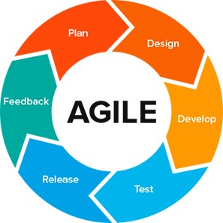

Figure 1. 1: Agile Methodology

1.6: Report Organization

This report is divided into six chapters:

Chapter 1: This chapter explains the reasons behind the development of the GoFood platform, including the problem it addresses, the project's objectives, its features, and the scope and limitations of the project.
Chapter 2: In this chapter, we review existing research and literature relevant to the project. We analyze journals, articles, and previous works to provide background and context for our project.
Chapter 3: This chapter focuses on the system analysis, including how we identified user requirements and assessed the feasibility of the platform.
Chapter 4: In this section, we cover the system design with detailed diagrams such as class diagrams, object diagrams, and activity diagrams, showing the structure of the platform.
Chapter 5: This chapter describes how the system was implemented and tested. We go over the tools and technologies used, along with the testing procedures to ensure functionality.
Chapter 6: Finally, we present the achievements of the project and provide recommendations for future improvements and potential developments.

CHAPTER 2:

BACKGROUND STUDY AND LITERATURE REVIEW

2.1 Background Study

The food delivery industry has undergone a digital revolution globally, with online platforms becoming a dominant force in the restaurant business. In Nepal, the adoption of food delivery apps has surged due to urbanization, increased smartphone usage, and the demand for convenience [1].

Traditional methods of ordering food—such as phone calls or walk-ins—are declining as consumers prefer the speed and variety offered by digital platforms. According to a study by Thapa [2].

Online food delivery services in Kathmandu Valley alone grew by 45% between 2020 and 2023, indicating a strong market shift towards digital solutions.

Restaurants, especially small and medium-sized eateries, benefit from these platforms by expanding their customer base without heavy marketing investments [3].

However, challenges such as delivery logistics in congested urban areas and limited internet penetration in rural regions still hinder widespread adoption [4].

Despite these barriers, the convenience of browsing menus, real-time order tracking, and cashless payments continues to drive growth in Nepal’s food tech sector.

2.1 Literature Review

Several studies highlight the impact of food delivery platforms on consumer behavior and restaurant operations. Research by Smith & Johnson found that user experience (UX) design significantly influences customer retention in food apps, with intuitive interfaces leading to higher order frequency.[5]

Similarly, a case study on Daraz Food revealed that Nepali consumers prioritize fast delivery times (under 45 minutes) and accurate food descriptions when choosing a platform. [6]

Another critical factor is trust and reliability. A survey by Foodmandu showed that 65% of users prefer platforms with verified restaurant ratings and secure payment options [7].

This aligns with global trends where transparency in pricing and hygiene standards builds long-term customer loyalty [8].

However, a gap exists in Nepal’s market regarding personalized recommendations and AI-driven customer support, areas where international platforms like Zomato and Uber Eats excel .

2.2.1 Study of Existing Systems
Some of the existing real estate platforms in Nepal include:

- Foodmandu: Foodmandu.com is Nepal’s first and leading food delivery service that connects customers with their favorite restaurants and food outlets. Operating mainly in urban areas, it allows users to order food online and get it delivered to their doorstep. It acts as a bridge between food lovers and restaurants, providing convenience and variety in one platform.

- Bhoj Deals: Bhojdeals.com is an online food ordering and delivery platform in Nepal. It partners with various restaurants to offer a wide selection of cuisines and dishes. Users can browse menus, place orders, and enjoy promotional deals. It serves as a digital bridge between customers and restaurants, making food ordering simple and accessible.

After examining these systems, we identified several areas for improvement:

-Limited advanced search capabilities

- Lack of virtual tour features

– Absence of comprehensive market insights and trend analysis tools

CHAPTER 3: SYSTEM ANALYSIS

System Analysis
Here, the focus is on understanding and defining the system's requirements and feasibility. The section describes the functional requirements through the illustration of use case diagrams, portraying user-system interactions. Non-functional requirements, encompassing aspects like performance and security, are also explored. Additionally, the feasibility analysis examines the technical, operational, economic, and scheduling aspects of the project. The chapter employs an object-oriented approach, utilizing tools such as ER diagrams for data modeling, class diagrams for object modeling, and activity diagrams for process modeling, to comprehensively analyze and design the system.

Requirement Analysis
The following are the key functional and non-functional requirements for GoFood:

Functional Requirements
- User Management:

  - User registration and authentication

- Role-based access control (Customer, admin)

- User profile management

- Food Listing:

  - Create, edit, and delete Food listings
  - Category division

- Admin Functions:

  - User management

  - Food and Restaurant listing moderation

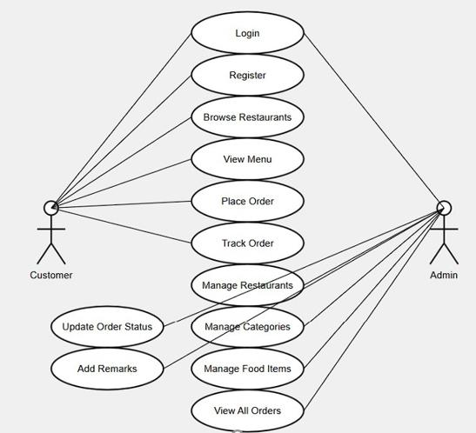

Figure 3. 1: Use Case Diagram
The figure above is the use case diagram of our proposed project GoFood. There are three actors: admin and Customer along with their respective use cases.

Use Case Description

Table 3. 1: Register Use Case Description

Use Case Name |  | Register
Scenario |  | Create user-account for Customer
Triggering event |  | User starts registration process
Brief description |  | User should be able to create his/her new account in order to order food.
Actors |  | Customer
Related use cases |  | Login
Stakeholders |  | Users (Customer), Admin
Preconditions |  | User should start the system
Preconditions |  | New user account is created
Flow of Activities | 1. | The user accesses the Registration page.
 | 2. | The user enters their personal information
 |  | into the registration form.
 | 3. | After submitting the credentials, the system
 |  | creates a new account for the user.
 | 4. | The user is redirected to the login page
Exception conditions |  | User provides incomplete or wrong information; the system must display suitable  error message to the user

Table 3. 2: Use Case Description of Admin

Use Case Name | Login
Actors | Admin
Preconditions | None
Primary Path | - Username  - Password  - Click on Login
Exception conditions | Invalid Credentials

Table 3. 3: Use Case Description of Customer (Login)

Use Case Name | Login
Actors | Seeker
Preconditions | None
Primary Path | - Email address  - Password  - Click on Login
Exception conditions | Fields are missing

Table 3. 4: Use Case Description of Customer

Use Case Name | Login
Actors | Seeker
Preconditions | Login
Primary Path | - View Food items.  - Order Food.  - Track Food Order
Exception conditions | User must be logged in to order food

Non-Functional Requirements:
- Security:

  - Secure user authentication (e.g., JWT (JSON Web Tokens), OAuth)

  - Data encryption for sensitive information

  - Protection against common web vulnerabilities (e.g., XSS, CSRF)

- Usability:

  - Intuitive and responsive user interface

- Compatibility:

  - Cross-browser compatibility (Chrome, Firefox, Safari, Edge)

  - Responsive design for mobile devices

Feasibility Study

Technical Feasibility
GoFood is technically feasible due to the following factors:
- PHP is a widely used, stable server-side language with extensive documentation and community support.
- The team has experience in web development and is familiar with HTML, CSS, JavaScript, and PHP-based systems.
- Required tools and technologies (e.g., MySQL, Apache/Nginx) are readily available and well-documented.

Integration of third-party services (e.g., mapping APIs, payment gateways) is possible through available APIs and JavaScript/PHP libraries.

Economical Feasibility
An economical feasibility study is an analysis of the costs and revenues of a project to determine whether it is logical and possible to complete it. It is a type of cost-benefit analysis that evaluates whether it is possible to implement the project. Our project is economically feasible as we are using freely available tools and software to build the project. Furthermore, after our project is successfully developed, collaborations with

recruiters and educational institutions further enhance revenue opportunities through strategic partnerships and targeted advertising.

Legal Feasibility
Legal feasibility refers to the evaluation of whether a software project can be implemented successfully based on legal and ethical requirements. It involves analyzing the barriers to legal implementation of the project, data protection or social media laws, project certificates, licenses, copyrights, etc. The project that we are developing is legally feasible as it does not break any legal rules.

Operational Feasibility
GoFood is operationally feasible because: - It addresses a clear need in the Nepali real estate market. - The user- friendly interface will encourage adoption by both tech- savvy and less technical users. - Regular updates and customer support will ensure smooth operation and user satisfaction.

Schedule Feasibility
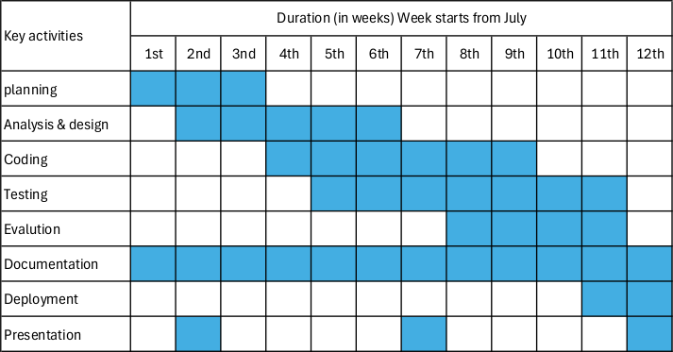
The project can be completed within the academic year, following this tentative schedule:

Figure 3. 2: Gantt chart of work schedule

Analysis

Class Diagram

A class diagram is a specific kind of UML (Unified Modelling Language) diagram,. that will be used to show how a system or software application is organized. It will provide a visual representation of a system's classes, interfaces, and objects, as well as their relationships, characteristics, methods, and activities.

For the GoFood project, a class diagram will be used to model the different entities involved in the system, such as users, orders, admin, etc.
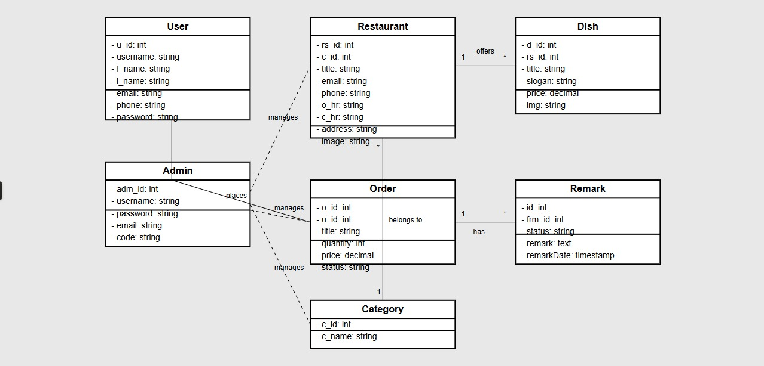
Figure 3. 3: Class Diagram for GoFood
The diagram provides a clear overview of the system’s functionality, showing how different users (Admin, Seeker, and Seller) interact with the property listings. Admins manage the system by adding or deleting properties and generating reports. Seekers can search for properties, view details. Sellers can list new properties, update existing listings, and manage their profiles.

Activity Diagram

An activity diagram is a type of UML (Unified Modelling Language) diagram that will show the flow of actions and events in a system or process. It will be used to model the dynamic behavior of a system, such as the interactions between actors, objects, and component.
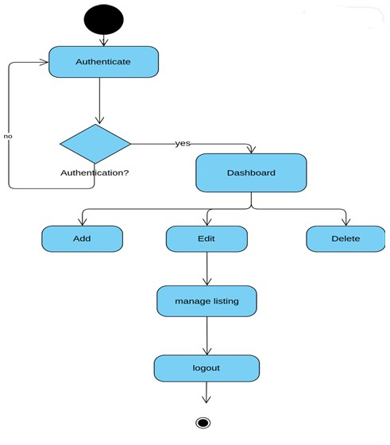

Figure 3. 4: Activity diagram of admin

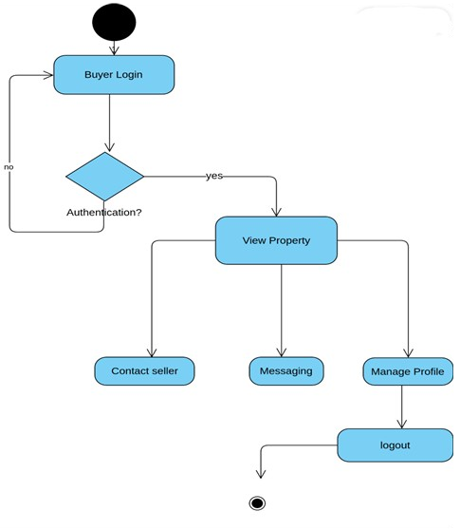
Manage profile
Log out
View cart
Add to cart
Browse item
Customer log inlog in
Figure 3. 6: Activity Diagram of Customer

The above activity diagram for a customer on outlines the customer’s journey from accessing the website to logging out. It includes actions like searching for food items, viewing food details, add to cart, and ordering the food. This visual representation helps understand the customer’s interactions and the system’s responses, ensuring a seamless and user-friendly experience.

CHAPTER 4: SYSTEM DESIGN

Design

System Architecture Diagram
System architecture design refers to the conceptual model that defines the structure, behaviors, and more views of a system. It is a blueprint for the system and the development
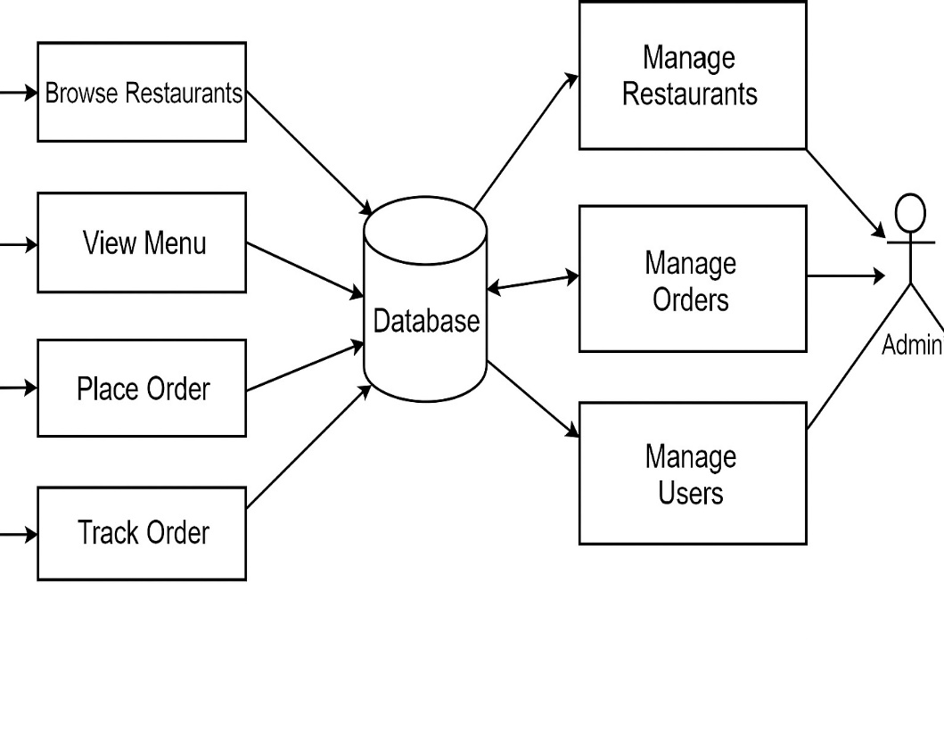
Customer

Figure 4. 1: Repository System Architecture Design

Figure above represents an interaction model between administrators, users, and the central database. Administrators have multiple functionalities: they can manage users, manage the property listings, and monitor the system activities. User begin with the registration process, after which they have the ability to search for Property, list Property for sell, and chat with owners.

Component Diagram

A component diagram is a type of Unified Modelling Language (UML) diagram that depicts the high-level structure of a system, showcasing the components that make up the system and their relationships.

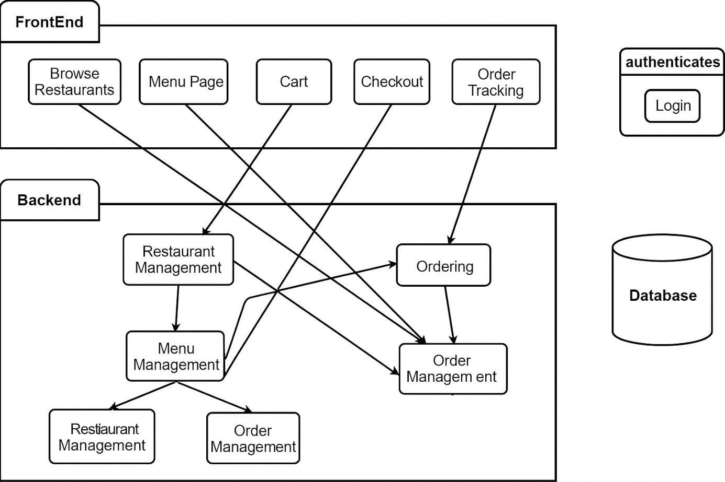
Figure 4. 2: Component Diagram

The component diagram outlines the architecture of a website system with interactions between various components. It shows that both Admin and User entities access the system through the Website. The main interface for both is the Homepage, which serves as a central hub, linking users to various functionalities such as Search, Register and Login. Once a user logs in, they can order food. The Admin Panel is accessible only after logging in and allows administrators to manage the website's content and operations. The diagram highlights how different components like the homepage, login system, and functionalities for users are interconnected, providing a clear flow of actions within the website system.

CHAPTER 5: IMPLEMENTATION AND TESTING

Implementing Tools

Frontend:

    - HTML: Defines the content and layout elements like headings, paragraphs, links, buttons, images, and more.
    - CSS: Controls the visual appearance — colors, fonts, spacing, layout, animations, responsiveness, etc.
    - JS: Adds interactivity and dynamic behavior to web pages.

Backend:

- PHP: Handles logic, processes form data, interacts with databases, and generates dynamic HTML content.
- MySQL: Stores and manages data in structured tables

Authentication: - JSON Web Tokens (JWT): For secure authentication and authorization.

Development and Deployment:

- Configuration Management Tool GitHub: GitHub is a popular version control system used in software configuration management. It provides a hosting platform for Git repositories, allowing us to store and manage the source code. It keeps track of changes made to the codebase over time, allowing us to view the entire version history of a project.
- Drawing Tool Draw.io: Draw.io, now known as diagrams.net, is a free and versatile online diagramming tool that allows users to create a wide range of diagrams, flowcharts, and other visual representations. It supports collaborative editing, integration with various cloud platforms, and provides an intuitive interface for creating and customizing diagrams. We used it for drawing use cases, activity, and class diagrams.

Development Tools:

- Visual Studio Code: As the primary code editor.
- XAMPP: For database management and visualization

: Testing
Testing was a crucial part of our project to ensure that the platform functions as intended and provides a smooth user experience. We implemented various testing methods to catch and fix issues at different stages of development.

: Unit Testing
We performed unit tests on individual components and functions to verify that each part of the code works correctly in isolation. This helped us catch bugs early and made debugging easier.

Test Case 1: User Login

Table 5. 1: Test case for User Login

SN | Test Inputs | Expected Outcomes | Actual Output | Results
1 | When user provides correct email and password.  Email: knowidont344@gmail.c om  Password: abcd123456 | Login should be success | Login successful and redirected to home page | Test successful
2 | When no email and password is provided: Email:  Password: | Invalid Credentials | Invalid Credentials | Test successful
3 | When username is provided with incorrect password.  Email: knowidont344@gmail.c om  Password: abcd1234567 | Invalid Credentials | Invalid Credentials | Test successful

Test Case 2: Admin Login

Table 5. 2: Test case for Admin Login

S.N | Test Inputs | Expected Outcomes | Actual Output | Results
1 | When the user provides correct email and password.  Email: knowidont344@gmail.c om  Password: abcd123456 | Login success | Login successful and redirected to Admin dashboard | Test successful
2 | When no email and password is provided:  Email: Password: | Invalid Credentials | Invalid Credentials | Test successful
3 | When username is provided with incorrect password. | Invalid Credentials | Invalid Credentials | Test successful

Test Case 3: User Registration

Table 5. 3: Test case for User Registration

S.N | Test Inputs | Expected Outcomes | Actual Output | Results
1 | Name: Kamal Subedi Email: knowidont344@gmail.c om  Password: abcd123456 Confirm Password:  abcd123456 | Successfully Registered. | Success (redirect to email verification page) | Test successful
2 | Email: knowidont344@gmail.c om  Password: abcd123456 Confirm Password:  abcd123456a | Password do not match | Password do not match | Test successful
3 | Email: Password:  Confirm Password: | Required Field | Email is invalid and Password must be at least 6 characters | Test successful
4 | If already existing email is entered while  registration. | Error Email exists. | Email already exists | Test successful

Test Cases for System Testing

System testing is defined as testing of a complete and fully integrated software product. System testing of software or hardware is testing conducted on a complete, integrated system to evaluate the system's compliance with its specified requirements. system testing falls within the scope of black box testing, and as such should require no knowledge of inner design of the code or logic. One of the types of system testing is the usability testing which is performed in the system.

Table 5. 4: Test Case for System Testing

Test  ID | Test Inputs | Expected Outcomes | Actual Output | Result
1 | User login successful, uploads, views, order. | Admin uploads the Food details and customer can navigate through it. |  | Test Successful

Table 5. 5: Test Case for System Usability Testing

Test  ID | Test Inputs | Expected Outcomes | Actual Output | Result
1 | Click on various links | Link should take | Users redirected | Test
 | on the system. | users to another | to expected | Successful
 |  | webpage according | webpages after
 |  | to the on-page | clicking the
 |  | URL. | links.

Table 5. 6: Test Case for Admin Functionality

Test  ID | Test Inputs | Expected Outcomes | Actual Output | Result
1 | Admin Login, food and Restaurant Listings. | Successful Completion of Admin Actions | Success | Test Successful

Result Analysis

The test results for the GoFood platform indicate that our system is robust in managing both admin and user interactions. The login functionalities are secure and user-friendly, with appropriate messages displayed for various scenarios such as invalid inputs or incomplete forms. The profile creation process is safeguarded against common issues, ensuring a smooth user experience.

All. test cases marked as "Test Successful" demonstrate that the system behaves as expected according to the defined requirements. The system has passed tests for various scenarios, covering a wide range of user inputs and interactions, and ensuring that it reacts appropriately. This includes functionalities for Seekers and property owners and administrative tasks.

Overall, the test results suggest that the GoFood website is operational, user- centric, and ready for deployment. The system is prepared to offer a seamless user experience and effectively serve its intended purpose in the market.

Chapter 6: Conclusion and Future Recommendations

Conclusion
The development of the "GoFood" platform has effectively met the need for a more dynamic and user-friendly online food ordering experience. By incorporating features such as restaurant surfing, food ordering and food tracking, the portal provides a comprehensive solution for food ordering .
The Agile methodology employed allowed us to continuously refine and enhance the platform based on user feedback and iterative testing. After rigorous evaluation, we have confirmed that the system is both reliable and efficient, positioning "GoFood" as a valuable tool for the online food ordering market. The successful implementation of this platform is set to improve restaurant surfing and food ordering, offering an accessible and streamlined experience for all users.

References

- Khanal, S. (2022). The Rise of Food Tech in Nepal. Himalayan Innovation Press.
- Thapa, B. (2023). Growth of Online Food Delivery in Kathmandu. Nepali Economic Review, 15(1), 78-95.
- Gurung, R. (2021). Digital Transformation of Nepal’s Restaurant Industry. Journal of Business & Technology Nepal, 12(3), 45-60.
- Nepal Telecom Authority. (2023). Internet Accessibility Report 2023. Government of Nepal.
- Smith, L., & Johnson, P. (2021). UX Design in Food Delivery Apps. International Journal of E-Commerce, 8(2), 112-130.
- Shrestha, A. (2022). Case Study: Daraz Food’s Market Penetration. Tribhuvan University Press.
- Foodmandu. (2023). Consumer Preferences in Online Food Delivery. Kathmandu: Foodmandu Research.
- WHO. (2022). Food Safety Standards in Digital Platforms. World Health Organization.

Appendix

Screenshot of Home Page

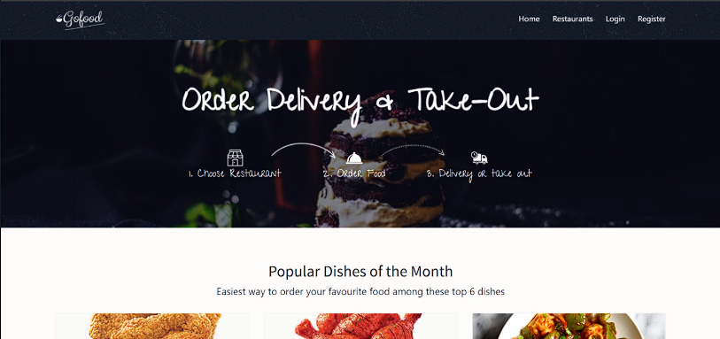

Screenshot of Register Page
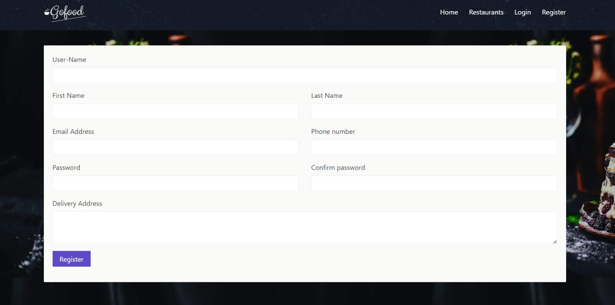

Screenshot of Login Page

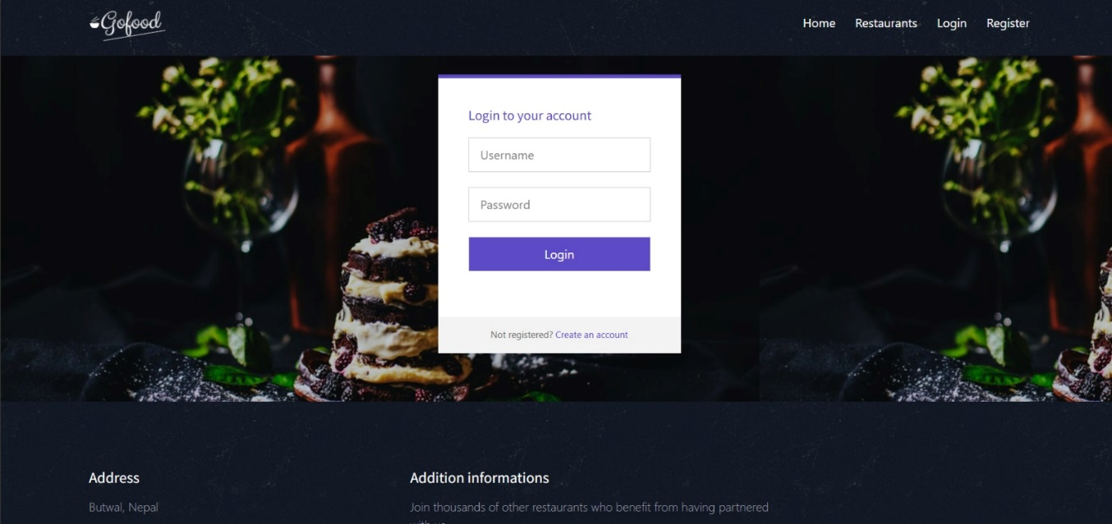

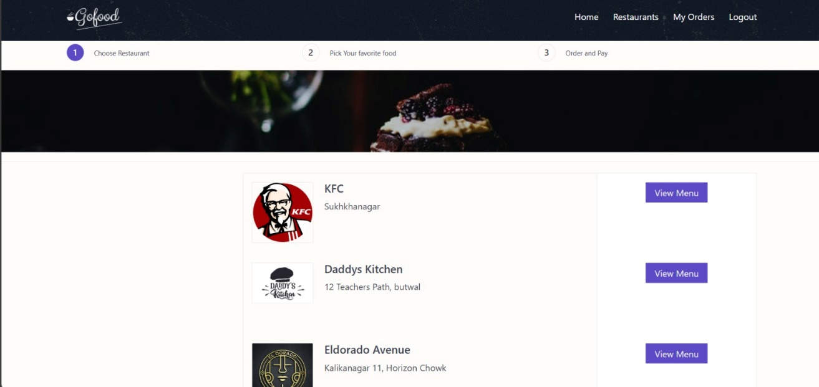
Screenshot of Restaurants

Screenshot of My Order
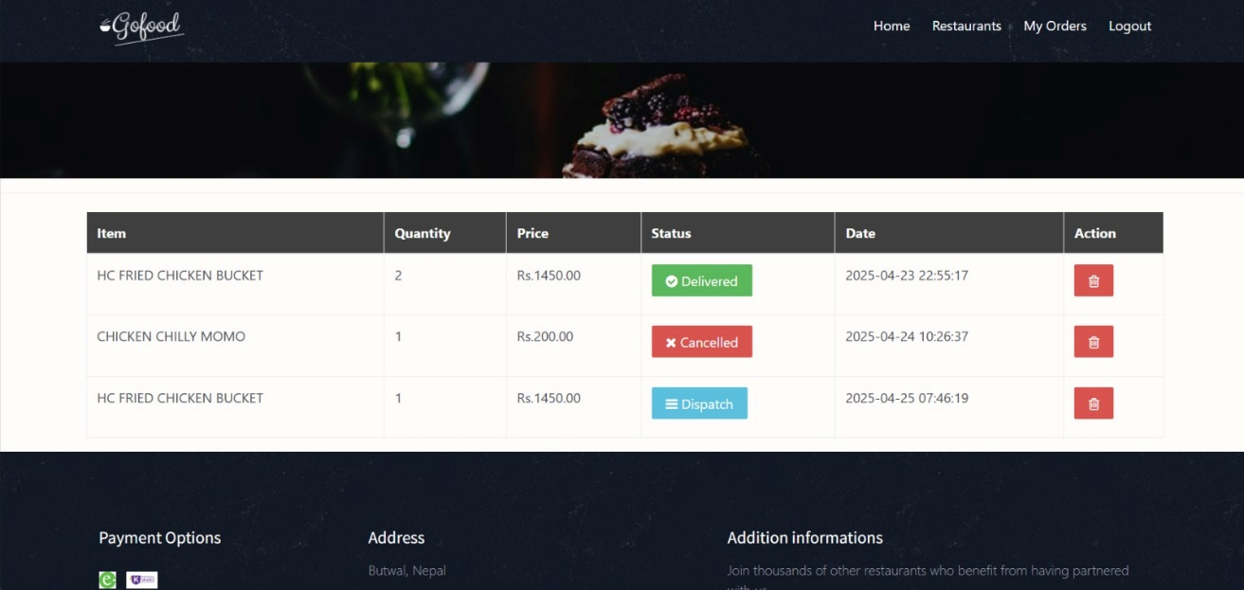

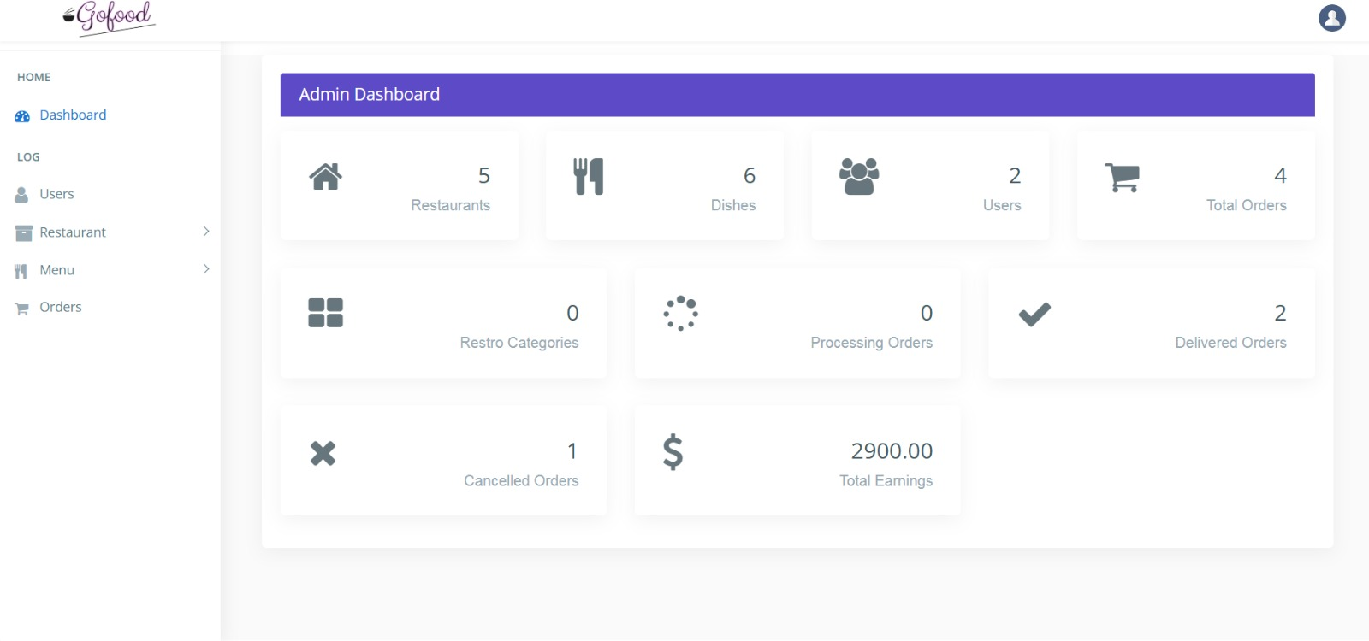
Screenshot of Admin Dashboard

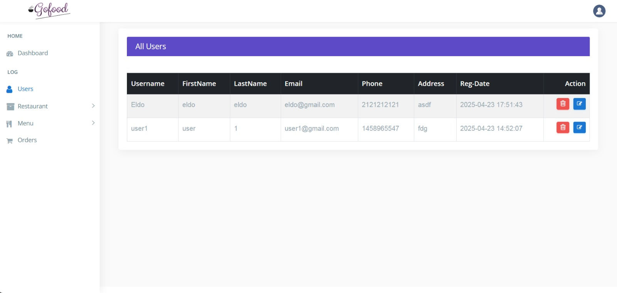
Screenshot of Admin User Access

Screenshot of All Menu Items
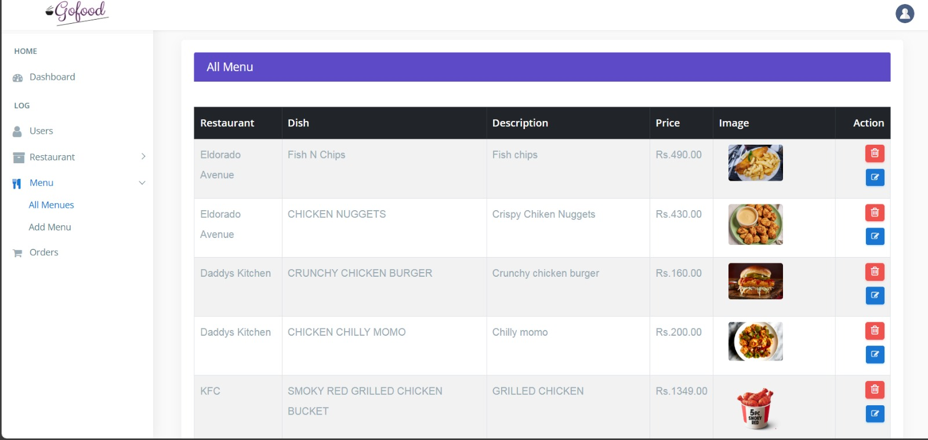

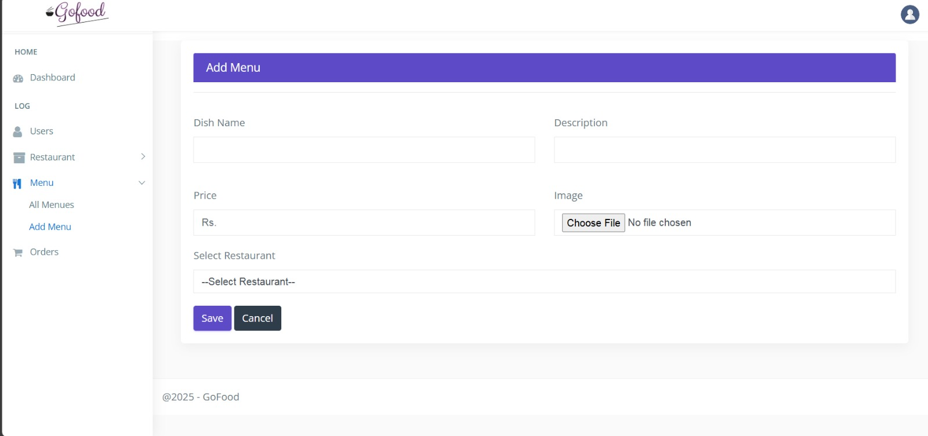
Screenshot of Add menu item

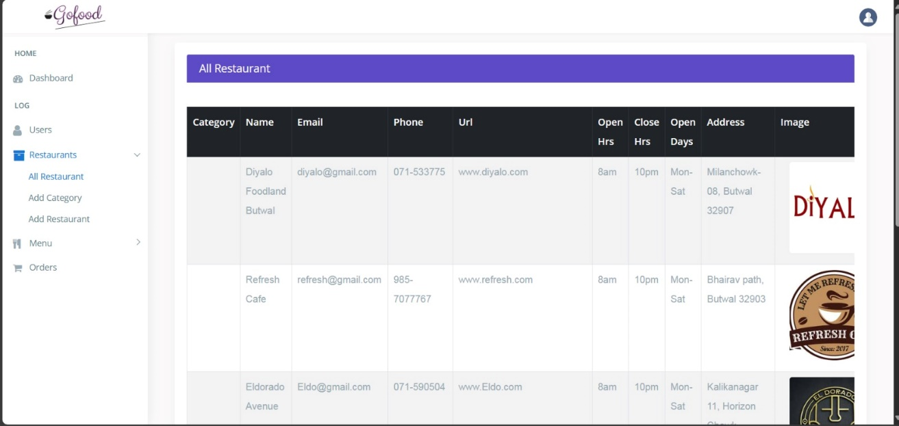
Screenshot of All Restaurant

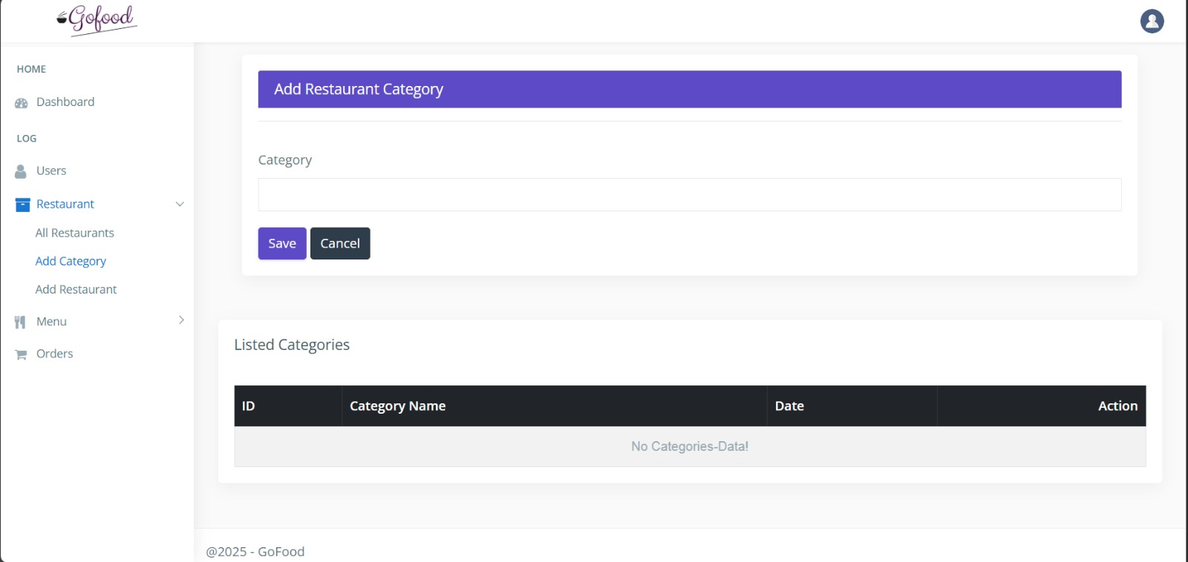
Screenshot of Add Category

Screenshot of Add Restaurants

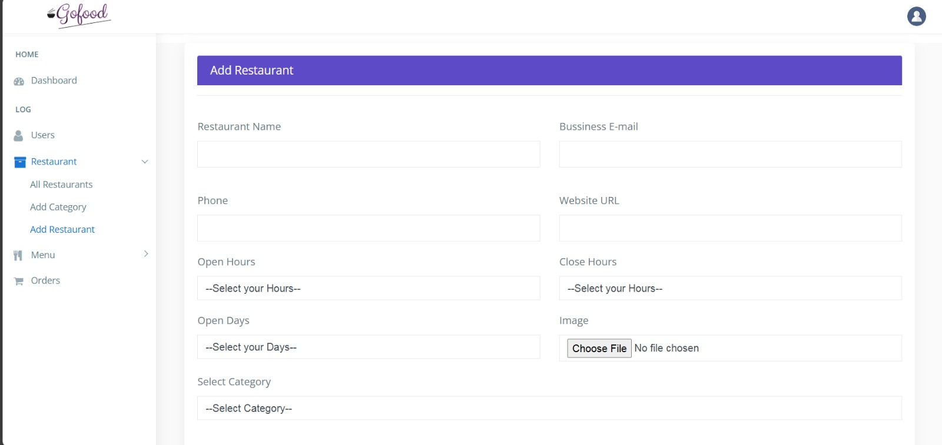

Screenshot of Admin Order Tracking

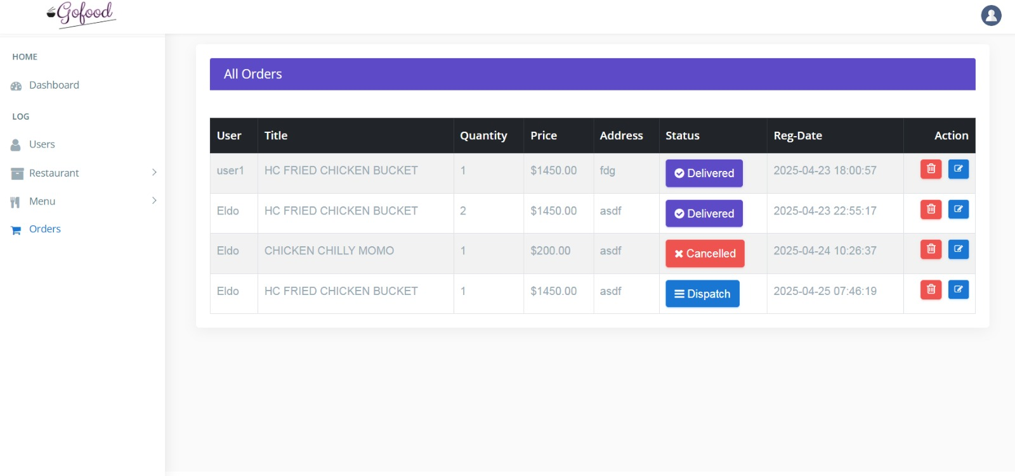

Screenshot of View Order

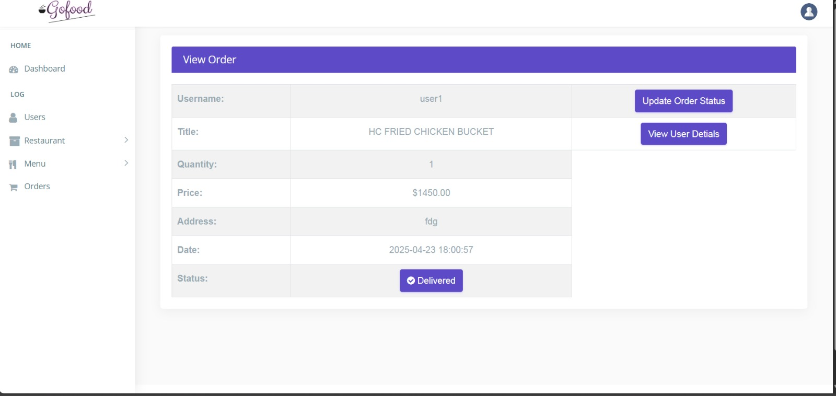

Screenshot of User Order Status

